SEC Form 3
FORM 3 | UNITED STATES SECURITIES AND EXCHANGE COMMISSION
 | Washington, D.C. 20549
 |  |  | OMB APPROVAL
 | INITIAL STATEMENT OF BENEFICIAL OWNERSHIP OF
 |  |  | OMB Number: | 3235-0104
 | SECURITIES |  | Estimated average burden
 |  |  | hours per response: | 0.5

Filed pursuant to Section 16(a) of the Securities Exchange Act of 1934
or Section 30(h) of the Investment Company Act of 1940
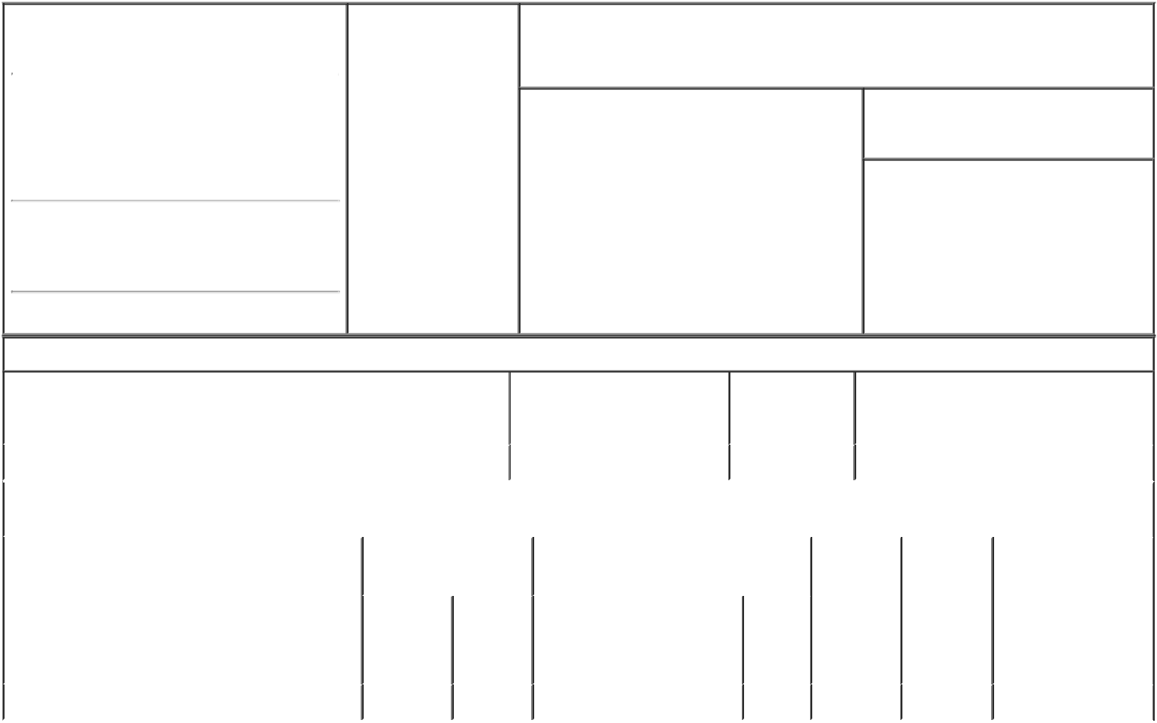

1. Name and Address of Reporting Person* |  |  |  | 2. Date of Event
 |  | HEALY JAMES |  | Requiring Statement
 |  |  |  | (Month/Day/Year)
 |  |  |  | 09/20/2018

3. Issuer Name and Ticker or Trading Symbol

Y-mAbs Therapeutics, Inc. [ YMAB ]

(Last) (First) (Middle)

C/O SOFINNOVA VENTURES, INC.

3000 SAND HILL ROAD, BLDG. 4, SUITE

250

(Street)
MENLO | CA | 94025
PARK

- Relationship of Reporting Person(s) to Issuer (Check all applicable)
X Director 10% Owner

Officer (give title Other (specify
below) below)

- If Amendment, Date of Original Filed (Month/Day/Year)

- Individual or Joint/Group Filing (Check Applicable Line)

- Form filed by One Reporting Person

Form filed by More than One Reporting Person

(City) (State) (Zip)

Table I - Non-Derivative Securities Beneficially Owned

1. Title of Security (Instr. 4) | 2. Amount of Securities | 3. Ownership | 4. Nature of Indirect Beneficial Ownership
 | Beneficially Owned (Instr. 4) | Form: Direct (D) | (Instr. 5)
 |  | or Indirect (I)
 |  | (Instr. 5)

 | Common Stock |  |  |  | 1,604,278 | I | See Footnote⁽¹⁾
 |  |  | Table II - Derivative Securities Beneficially Owned
 |  | (e.g., puts, calls, warrants, options, convertible securities)
 | 1. Title of Derivative Security (Instr. 4) |  | 2. Date Exercisable and |  | 3. Title and Amount of Securities |  | 4. | 5. | 6. Nature of Indirect
 |  |  | Expiration Date |  | Underlying Derivative Security (Instr. 4) |  | Conversion | Ownership | Beneficial Ownership
 |  |  | (Month/Day/Year) |  |  |  | or Exercise | Form: | (Instr. 5)
 |  |  |  |  |  |  | Price of | Direct (D)
 |  |  |  |  |  | Amount
 |  |  |  |  |  |  | Derivative | or Indirect
 |  |  |  |  |  | or | Security | (I) (Instr. 5)
 |  |  |  |  |  | Number
 |  |  | Date | Expiration |  | of
 |  |  | Exercisable | Date | Title | Shares
 | Non-Employee Stock Option (right to buy) | (2) |  | 04/24/2028 | Common Stock | 32,000 | 11.16 | D
 | Explanation of Responses:

- 1,604,278 shares of the Company's Common Stock is owned by Sofinnova Venture Partners X, L.P., or Sofinnova. The Reporting Person is a managing member of Sofinnova Management X, L.L.C., the General Partner of Sofinnova, and as such has voting and dispositive power over such shares with Dr. Anand Mehra and Michael F. Powell, Ph.D., the other managing members of Sofinnova Management X, L.L.C.

- 1/36th of the shares of the option to vest in equal monthly installments starting April 24, 2018 until such time as the option is 100% vested, subject to the Reporting Person continuing to be a service provider on each vesting date.

/s/ James I. Healy |  | 09/20/2018
** Signature of Reporting Person |  | Date

Reminder: Report on a separate line for each class of securities beneficially owned directly or indirectly.

* If the form is filed by more than one reporting person, see Instruction 5 (b)(v).

- Intentional misstatements or omissions of facts constitute Federal Criminal Violations See 18 U.S.C. 1001 and 15 U.S.C. 78ff(a). Note: File three copies of this Form, one of which must be manually signed. If space is insufficient, see Instruction 6 for procedure.
Persons who respond to the collection of information contained in this form are not required to respond unless the form displays a currently valid OMB Number.

