SEC Form 4

FORM 4

Check this box if no longer subject to Section 16. Form 4 or Form 5 obligations may continue. See Instruction 1(b).

UNITED STATES SECURITIES AND EXCHANGE COMMISSION
Washington, D.C. 20549
 |  | OMB APPROVAL
STATEMENT OF CHANGES IN BENEFICIAL OWNERSHIP
 |  | OMB Number: | 3235-0287
 |  | Estimated average burden
Filed pursuant to Section 16(a) of the Securities Exchange Act of 1934 |  | hours per response: | 0.5
or Section 30(h) of the Investment Company Act of 1940
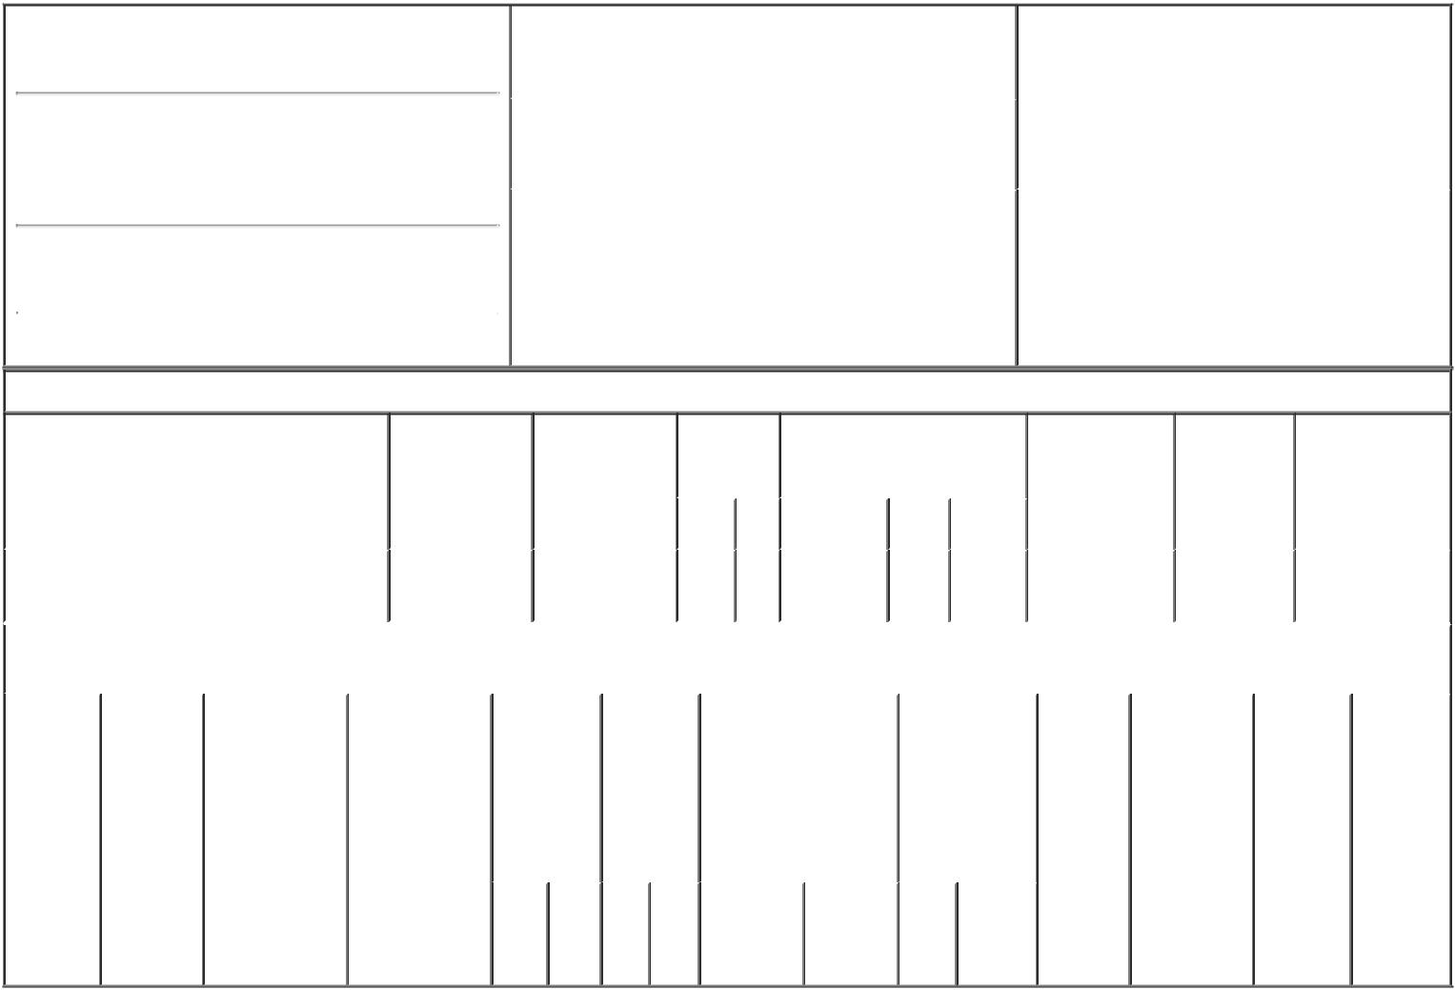

1. Name and Address of Reporting Person*
TYAGI ASHU

(Last) (First) (Middle)

C/O SCOPIA CAPITAL MANAGEMENT LP 152 WEST 57TH STREET

(Street)
 | NEW YORK | NY | 10019
 | (City) | (State) | (Zip)

2. |  | Issuer Name and Ticker or Trading Symbol |  | 5. | Relationship of Reporting Person(s) to Issuer
 | Y-mAbs Therapeutics, Inc. [ YMAB ] |  |  | (Check all applicable)
 |  |  |  |  | X Director | 10% Owner
 |  |  |  |  | Officer (give title | Other (specify
3. |  | Date of Earliest Transaction (Month/Day/Year)
 |  |  |  |  | below) | below)
09/25/2018
4. |  | If Amendment, Date of Original Filed (Month/Day/Year) |  | 6. | Individual or Joint/Group Filing (Check Applicable
Line)
X Form filed by One Reporting Person

Form filed by More than One Reporting
Person

Table I - Non-Derivative Securities Acquired, Disposed of, or Beneficially Owned

 | 1. Title of Security (Instr. 3) |  |  | 2. Transaction |  | 2A. Deemed |  |  | 3. | 4. Securities Acquired (A) or |  |  |  | 5. Amount of |  |  | 6. Ownership |  | 7. Nature of
 |  |  |  | Date |  | Execution Date, |  |  | Transaction | Disposed Of (D) (Instr. 3, 4 and |  |  |  | Securities |  |  | Form: Direct |  | Indirect Beneficial
 |  |  |  | (Month/Day/Year) |  | if any |  |  | Code (Instr. | 5) |  |  |  | Beneficially |  |  | (D) or Indirect |  | Ownership (Instr.
 |  |  |  |  |  | (Month/Day/Year) |  |  | 8) |  |  |  |  | Owned Following |  |  | (I) (Instr. 4) |  | 4)
 |  |  |  |  |  |  |  |  |  |  |  |  |  | Reported
 |  |  |  |  |  |  |  |  | Code V | Amount | (A) or | Price |  | Transaction(s)
 |  |  |  |  |  |  |  |  |  |  | (D) |  |  | (Instr. 3 and 4)
 | Common Stock |  |  | 09/25/2018 |  |  |  |  | P | 430,174 | A | $16 |  | 1,392,740 |  |  | I |  | See
 |  |  |  |  |  |  |  |  |  |  |  |  |  |  |  |  |  |  | Footnotes⁽¹⁾⁽²⁾⁽³⁾
 |  |  | Table II - Derivative Securities Acquired, Disposed of, or Beneficially Owned
 |  |  |  | (e.g., puts, calls, warrants, options, convertible securities)
 | 1. Title of | 2. | 3. Transaction | 3A. Deemed | 4. |  | 5. Number |  | 6. Date Exercisable and |  | 7. Title and |  |  |  | 8. Price of | 9. Number of |  | 10. |  | 11. Nature
 | Derivative | Conversion | Date | Execution Date, | Transaction |  | of |  | Expiration Date |  | Amount of |  |  |  | Derivative | derivative |  | Ownership |  | of Indirect
 | Security | or Exercise | (Month/Day/Year) | if any | Code (Instr. |  | Derivative |  | (Month/Day/Year) |  | Securities |  |  |  | Security | Securities |  | Form: |  | Beneficial
 | (Instr. 3) | Price of |  | (Month/Day/Year) | 8) |  | Securities |  |  |  | Underlying |  |  |  | (Instr. 5) | Beneficially |  | Direct (D) |  | Ownership
 |  | Derivative |  |  |  |  | Acquired |  |  |  | Derivative |  |  |  |  | Owned |  | or Indirect |  | (Instr. 4)
 |  | Security |  |  |  |  | (A) or |  |  |  | Security (Instr. 3 |  |  |  |  | Following |  | (I) (Instr. 4)
 |  |  |  |  |  |  | Disposed |  |  |  | and 4) |  |  |  |  | Reported
 |  |  |  |  |  |  | of (D) |  |  |  |  |  |  |  |  | Transaction(s)
 |  |  |  |  |  |  | (Instr. 3, 4 |  |  |  |  |  |  |  |  | (Instr. 4)
 |  |  |  |  |  |  | and 5)
 |  |  |  |  |  |  |  |  |  |  |  | Amount
 |  |  |  |  |  |  |  |  |  |  |  | or
 |  |  |  |  |  |  |  |  |  |  |  | Number
 |  |  |  |  |  |  |  |  | Date | Expiration |  | of
 |  |  |  |  | Code | V | (A) (D) |  | Exercisable Date |  | Title | Shares

Explanation of Responses:

- The securities reported in this Form 4 are held in the accounts of certain private investment funds, specifically, Scopia Health Care International Master Fund LP ("Scopia Health International") and Scopia Health Care LLC ("Scopia Health LLC", and together with Scopia Health International, the "Investment Vehicles"). Following reported transaction, Scopia Health International holds 1,067,933 shares of the Company's common stock and Scopia Health LLC holds 324,807 shares of the Company's common stock. Scopia Capital Management LP ("Scopia Management") serves as the investment manager of the Investment Vehicles and has sole voting and investment power over the Company's securities held by the Investment Vehicles. Reporting Person may be deemed to exercise voting and investment power over the Company's securities held by the Investment Vehicles as a partner of Scopia Management.

- Further, Reporting Person may be deemed to have a pecuniary interest in a portion of the securities held directly by the Investment Vehicles due to the right of an affiliate of Scopia Management to receive performance-based allocations and due to Reporting Person's investments in the Investment Vehicles.

- Reporting Person disclaims beneficial ownership of the securities reported herein except to the extent of his pecuniary interest therein, and this report shall not be deemed an admission that Reporting Person is the beneficial owner of such securities for purposes of Section 16 of the Securities Exchange Act of 1934, as amended, or for any other purpose.

/s/ Ashutosh Tyagi |  | 09/26/2018
** Signature of Reporting Person |  | Date

Reminder: Report on a separate line for each class of securities beneficially owned directly or indirectly.

* If the form is filed by more than one reporting person, see Instruction 4 (b)(v).

- Intentional misstatements or omissions of facts constitute Federal Criminal Violations See 18 U.S.C. 1001 and 15 U.S.C. 78ff(a). Note: File three copies of this Form, one of which must be manually signed. If space is insufficient, see Instruction 6 for procedure.
Persons who respond to the collection of information contained in this form are not required to respond unless the form displays a currently valid OMB Number.

