SEC Form 4

FORM 4

Check this box if no longer subject to Section 16. Form 4 or Form 5 obligations may continue. See Instruction 1(b).

UNITED STATES SECURITIES AND EXCHANGE COMMISSION
Washington, D.C. 20549
 |  | OMB APPROVAL
STATEMENT OF CHANGES IN BENEFICIAL OWNERSHIP
 |  | OMB Number: | 3235-0287
 |  | Estimated average burden
Filed pursuant to Section 16(a) of the Securities Exchange Act of 1934 |  | hours per response: | 0.5
or Section 30(h) of the Investment Company Act of 1940
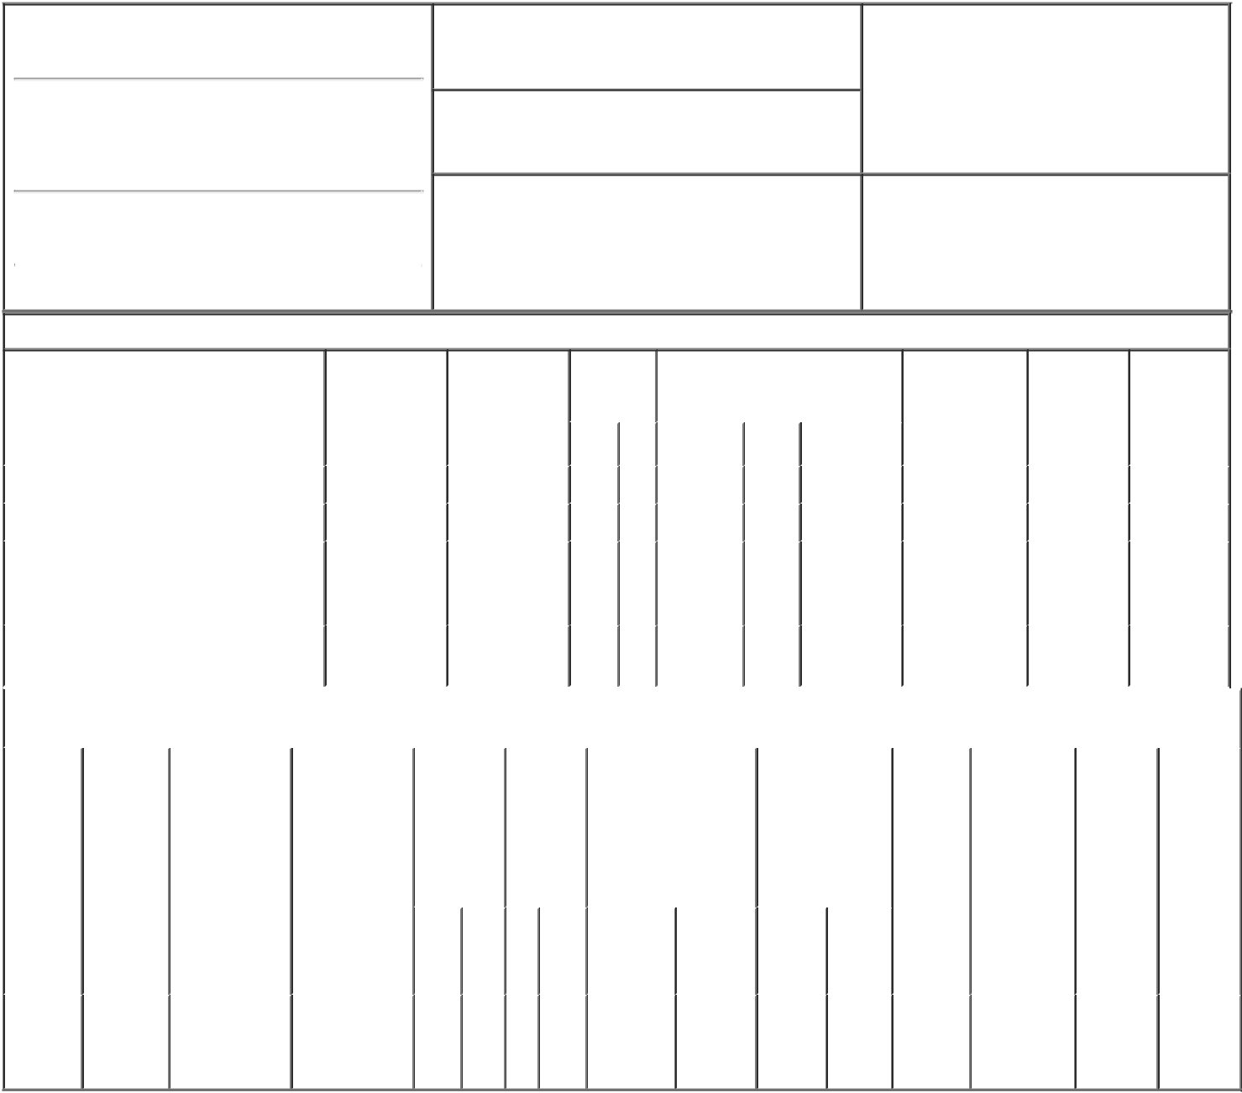

1. Name and Address of Reporting Person*
Gad Thomas

(Last) (First) (Middle)

C/O Y-MABS THERAPEUTICS, INC.

230 PARK AVENUE, SUITE 3350

2. Issuer Name and Ticker or Trading Symbol

Y-mAbs Therapeutics, Inc. [ YMAB ]

3. Date of Earliest Transaction (Month/Day/Year)
02/01/2022

- Relationship of Reporting Person(s) to Issuer (Check all applicable)

X | Director | 10% Owner
X | Officer (give title | Other (specify
 | below) | below)

See remarks

(Street)
 | NEW YORK | NY | 10169
 | (City) | (State) | (Zip)

4. If Amendment, Date of Original Filed (Month/Day/Year) 6. Individual or Joint/Group Filing (Check Applicable
Line)
X Form filed by One Reporting Person

Form filed by More than One Reporting
Person

Table I - Non-Derivative Securities Acquired, Disposed of, or Beneficially Owned

 | 1. Title of Security (Instr. 3) |  |  | 2. Transaction |  |  | 2A. Deemed |  |  | 3. |  | 4. Securities Acquired (A) or |  |  |  |  |  | 5. Amount of |  | 6. Ownership |  | 7. Nature of
 |  |  |  | Date |  |  | Execution Date, |  |  | Transaction |  | Disposed Of (D) (Instr. 3, 4 and 5) |  |  |  |  |  | Securities |  | Form: Direct |  | Indirect
 |  |  |  | (Month/Day/Year) |  |  | if any |  |  | Code (Instr. |  |  |  |  |  |  |  | Beneficially |  | (D) or Indirect |  | Beneficial
 |  |  |  |  |  |  | (Month/Day/Year) |  |  | 8) |  |  |  |  |  |  |  | Owned Following |  | (I) (Instr. 4) |  | Ownership
 |  |  |  |  |  |  |  |  |  |  |  |  |  |  |  |  |  | Reported |  |  |  | (Instr. 4)
 |  |  |  |  |  |  |  |  |  | Code | V | Amount | (A) or | Price |  |  |  | Transaction(s)
 |  |  |  |  |  |  |  |  |  |  |  |  | (D) |  |  |  |  | (Instr. 3 and 4)
 | Common Stock |  |  | 02/01/2022 |  |  |  |  |  | M |  | 8,000 | A |  | _{$2}(1) |  | 58,000 |  |  |  | D
 | Common Stock |  |  | 02/01/2022 |  |  |  |  |  | S |  | 8,000 | _{D}(2) | $10.1451⁽³⁾ |  |  | 50,000 |  |  |  | D
 |  |  |  |  |  |  |  |  |  |  |  |  |  |  |  |  |  |  |  |  |  | By GAD
 | Common Stock |  |  |  |  |  |  |  |  |  |  |  |  |  |  |  | 982,366 |  |  |  | I | Enterprises
 |  |  |  |  |  |  |  |  |  |  |  |  |  |  |  |  |  |  |  |  |  | _{LLC}(4)
 | Common Stock |  |  |  |  |  |  |  |  |  |  |  |  |  |  |  | 60,000 |  |  |  | I | By
 |  |  |  |  |  |  |  |  |  |  |  |  |  |  |  |  |  |  |  |  |  | Children⁽⁵⁾
 |  |  | Table II - Derivative Securities Acquired, Disposed of, or Beneficially Owned
 |  |  |  | (e.g., puts, calls, warrants, options, convertible securities)
 | 1. Title of | 2. | 3. Transaction | 3A. Deemed |  | 4. |  | 5. Number |  | 6. Date Exercisable and |  |  | 7. Title and |  |  |  | 8. Price of |  | 9. Number of |  | 10. |  | 11. Nature
 | Derivative | Conversion | Date | Execution Date, |  | Transaction |  | of |  | Expiration Date |  |  | Amount of |  |  |  | Derivative |  | derivative |  | Ownership |  | of Indirect
 | Security | or Exercise | (Month/Day/Year) | if any |  | Code (Instr. |  | Derivative |  | (Month/Day/Year) |  |  | Securities |  |  |  | Security |  | Securities |  | Form: |  | Beneficial
 | (Instr. 3) | Price of |  | (Month/Day/Year) |  | 8) |  | Securities |  |  |  |  | Underlying |  |  |  | (Instr. 5) |  | Beneficially |  | Direct (D) |  | Ownership
 |  | Derivative |  |  |  |  |  | Acquired |  |  |  |  | Derivative Security |  |  |  |  |  | Owned |  | or Indirect |  | (Instr. 4)
 |  | Security |  |  |  |  |  | (A) or |  |  |  |  | (Instr. 3 and 4) |  |  |  |  |  | Following |  | (I) (Instr. 4)
 |  |  |  |  |  |  |  | Disposed |  |  |  |  |  |  |  |  |  |  | Reported
 |  |  |  |  |  |  |  | of (D) |  |  |  |  |  |  |  |  |  |  | Transaction(s)
 |  |  |  |  |  |  |  | (Instr. 3, 4 |  |  |  |  |  |  |  |  |  |  | (Instr. 4)
 |  |  |  |  |  |  |  | and 5)
 |  |  |  |  |  |  |  |  |  |  |  |  |  |  | Amount
 |  |  |  |  |  |  |  |  |  |  |  |  |  |  | or
 |  |  |  |  |  |  |  |  |  |  |  |  |  |  | Number
 |  |  |  |  |  |  |  |  |  | Date |  | Expiration |  |  | of
 |  |  |  |  |  | Code | V | (A) (D) |  | Exercisable Date |  |  | Title |  | Shares
 | Employee
 | Stock |  |  |  |  |  |  |  |  |  | (6) |  | Common |  | 8,000
 | Option | $2 | 02/01/2022 |  |  | M |  | 8,000 |  |  |  | 06/10/2025 |  |  |  |  | $0 |  | 153,000 |  | D
 | (right to |  |  |  |  |  |  |  |  |  |  |  | Stock
buy)

Explanation of Responses:

- Represents shares acquired through the exercise of Employee Stock Options.

- Represents shares sold pursuant to a Rule 10b5-1 trading plan adopted on 12/14/2021.

- This transaction was executed in multiple trades at prices ranging from $9.91 to $10.33. The price reported reflects the weighted average sale price. The Reporting Person hereby undertakes to provide upon request to the SEC staff, the issuer or a security holder of the Issuer full information regarding the number of shares and prices at which the transaction was effected.
- Reporting Person is sole member of GAD Enterprises, LLC and the sole member and manager of GAD Management, LLC, the manager of GAD Enterprises, LLC, and as such Reporting Person has sole voting and dispositive power with respect to such shares.

- Represents shares owned by Reporting Person's children who are deemed to share Reporting Person's household.

- The stock option vested and became exercisable as to 25% of the shares subject to the option on June 10, 2016, and thereafter vested as to 1/48th of the shares in equal monthly installments, until such time as the option was 100% vested on June 10, 2019.

Remarks:

Chairman, President and Head of Business Development & Strategy

/s/ THOMAS GAD |  | 02/02/2022
** Signature of Reporting Person |  | Date

Reminder: Report on a separate line for each class of securities beneficially owned directly or indirectly.

* If the form is filed by more than one reporting person, see Instruction 4 (b)(v).

- Intentional misstatements or omissions of facts constitute Federal Criminal Violations See 18 U.S.C. 1001 and 15 U.S.C. 78ff(a). Note: File three copies of this Form, one of which must be manually signed. If space is insufficient, see Instruction 6 for procedure.
Persons who respond to the collection of information contained in this form are not required to respond unless the form displays a currently valid OMB Number.

