UNITED STATES
SECURITIES AND EXCHANGE COMMISSION
Washington, D.C. 20549
SCHEDULE 14A
Proxy Statement Pursuant to Section 14(a) of
the Securities Exchange Act of 1934 (Amendment No. )
​ | ​
Filed by the Registrant ⌧
​
Filed by a Party other than the Registrant ☐
​
Check the appropriate box:
☐ | Preliminary Proxy Statement
☐ | Confidential, for Use of the Commission Only (as permitted by Rule 14a-6(e)(2))
☐ | Definitive Proxy Statement
⌧ | Definitive Additional Materials
☐ | Soliciting Material under §240.14a-12
​
​
​ | ​ | ​
Y-MABS THERAPEUTICS, INC.
(Name of Registrant as Specified In Its Charter)
​
(Name of Person(s) Filing Proxy Statement, if other than the Registrant)
​
Payment of Filing Fee (Check the appropriate box):
⌧ | No fee required.
☐ | Fee paid previously with preliminary materials.
☐ | Fee computed on table in exhibit required by Item 25(b) per Exchange Act Rules 14a-6(i)(1) and 0-11.
​
​

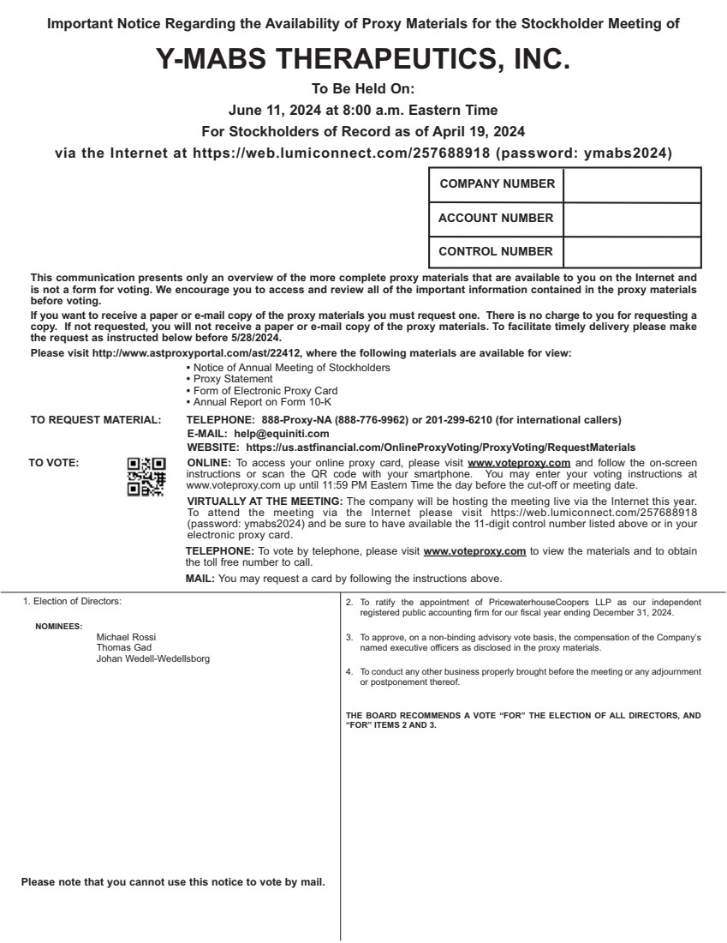 | 1. Election of Directors: Michael Rossi Thomas Gad Johan Wedell-Wedellsborg 2. To ratify the appointment of PricewaterhouseCoopers LLP as our independent registered public accounting firm for our fiscal year ending December 31, 2024. 3. To approve, on a non-binding advisory vote basis, the compensation of the Company’s named executive officers as disclosed in the proxy materials. 4. To conduct any other business properly brought before the meeting or any adjournment or postponement thereof. THE BOARD RECOMMENDS A VOTE “FOR” THE ELECTION OF ALL DIRECTORS, AND “FOR” ITEMS 2 AND 3. NOMINEES: This communication presents only an overview of the more complete proxy materials that are available to you on the Internet and is not a form for voting. We encourage you to access and review all of the important information contained in the proxy materials before voting. If you want to receive a paper or e-mail copy of the proxy materials you must request one. There is no charge to you for requesting a copy. If not requested, you will not receive a paper or e-mail copy of the proxy materials. To facilitate timely delivery please make the request as instructed below before 5/28/2024. Please visit http://www.astproxyportal.com/ast/22412, where the following materials are available for view: • Notice of Annual Meeting of Stockholders • Proxy Statement • Form of Electronic Proxy Card • Annual Report on Form 10-K TO REQUEST MATERIAL: TELEPHONE: 888-Proxy-NA (888-776-9962) or 201-299-6210 (for international callers) E-MAIL: help@equiniti.com WEBSITE: https://us.astfinancial.com/OnlineProxyVoting/ProxyVoting/RequestMaterials TO VOTE: ONLINE: To access your online proxy card, please visit www.voteproxy.com and follow the on-screen instructions or scan the QR code with your smartphone. You may enter your voting instructions at www.voteproxy.com up until 11:59 PM Eastern Time the day before the cut-off or meeting date. VIRTUALLY AT THE MEETING: The company will be hosting the meeting live via the Internet this year. To attend the meeting via the Internet please visit https://web.lumiconnect.com/257688918 (password: ymabs2024) and be sure to have available the 11-digit control number listed above or in your electronic proxy card. TELEPHONE: To vote by telephone, please visit www.voteproxy.com to view the materials and to obtain the toll free number to call. MAIL: You may request a card by following the instructions above. COMPANY NUMBER ACCOUNT NUMBER CONTROL NUMBER JOHN SMITH 1234 MAIN STREET APT. 203 NEW YORK, NY 10038 Please note that you cannot use this notice to vote by mail. Important Notice Regarding the Availability of Proxy Materials for the Stockholder Meeting of Y-MABS THERAPEUTICS, INC. To Be Held On: June 11, 2024 at 8:00 a.m. Eastern Time For Stockholders of Record as of April 19, 2024 via the Internet at https://web.lumiconnect.com/257688918 (password: ymabs2024)

