SEC Form 3
FORM 3 | UNITED STATES SECURITIES AND EXCHANGE COMMISSION
 | Washington, D.C. 20549
 |  |  | OMB APPROVAL
 | INITIAL STATEMENT OF BENEFICIAL OWNERSHIP OF
 |  |  | OMB Number: | 3235-0104
 | SECURITIES |  | Estimated average burden
 |  |  | hours per response: | 0.5

Filed pursuant to Section 16(a) of the Securities Exchange Act of 1934
or Section 30(h) of the Investment Company Act of 1940
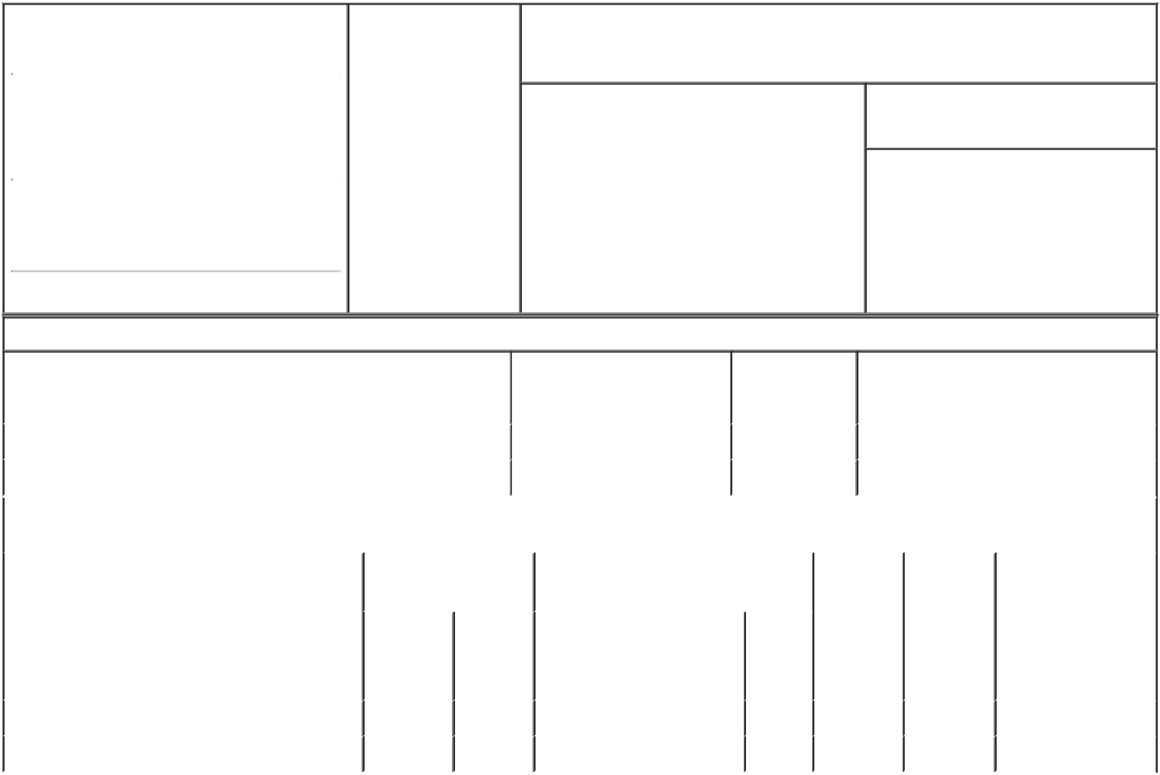

1. Name and Address of Reporting Person* |  |  |  | 2. Date of Event
 |  | Wedell-Wedellsborg Johan |  | Requiring Statement
 |  |  |  | (Month/Day/Year)
 |  |  |  | 09/20/2018

3. Issuer Name and Ticker or Trading Symbol

Y-mAbs Therapeutics, Inc. [ YMAB ]

 | (Last) | (First) | (Middle)
 | C/O WECO GROUP A/S
 | RUNGSTED STRANDVEJ 113
(Street)
 | RUNGSTED | G7 | 2960
 | KYST

- Relationship of Reporting Person(s) to Issuer (Check all applicable)
X Director X 10% Owner

Officer (give title Other (specify
below) below)

- If Amendment, Date of Original Filed (Month/Day/Year)

- Individual or Joint/Group Filing (Check Applicable Line)

- Form filed by One Reporting Person

Form filed by More than One Reporting Person

(City) (State) (Zip)

Table I - Non-Derivative Securities Beneficially Owned

1. Title of Security (Instr. 4) | 2. Amount of Securities | 3. Ownership | 4. Nature of Indirect Beneficial Ownership
 | Beneficially Owned (Instr. 4) | Form: Direct (D) | (Instr. 5)
 |  | or Indirect (I)
 |  | (Instr. 5)

 | Common Stock |  |  |  | 1,683,496 | I | By Weco Group A/S⁽¹⁾
 | Common Stock |  |  |  | 5,010,000 | I | By WG Biotech ApS⁽²⁾
 |  |  | Table II - Derivative Securities Beneficially Owned
 |  | (e.g., puts, calls, warrants, options, convertible securities)
 | 1. Title of Derivative Security (Instr. 4) |  | 2. Date Exercisable and |  | 3. Title and Amount of Securities |  | 4. | 5. | 6. Nature of Indirect
 |  |  | Expiration Date |  | Underlying Derivative Security (Instr. 4) |  | Conversion | Ownership | Beneficial Ownership
 |  |  | (Month/Day/Year) |  |  |  | or Exercise | Form: | (Instr. 5)
 |  |  |  |  |  |  | Price of | Direct (D)
 |  |  |  |  |  | Amount
 |  |  |  |  |  |  | Derivative | or Indirect
 |  |  |  |  |  | or | Security | (I) (Instr. 5)
 |  |  |  |  |  | Number
 |  |  | Date | Expiration |  | of
 |  |  | Exercisable | Date | Title | Shares
 | Non-Employee Stock Option (right to buy) | (3) |  | 10/21/2026 | Common Stock | 36,000 | 4.38 | D
 | Non-Employee Stock Option (right to buy) | (4) |  | 04/24/2028 | Common Stock | 32,000 | 11.16 | D
 | Explanation of Responses:

- Reporting Person is the majority owner of Weco Group A/S and as such has sole voting and dispositive power with respect to such shares.

- Reporting Person is the majority owner of WG Biotech ApS and as such has sole voting and dispositive power with respect to such shares.

- The stock option vested and became exercisable as to 33% of the shares subject to the option on October 21, 2016, and thereafter vests as to 1/36th of the shares in equal monthly installments, until such time as the option is 100% vested, subject to the Reporting Person being a service provider on each vesting date.

- 1/36th of the shares of the option to vest in equal monthly installments starting April 24, 2018 until such time as the option is 100% vested, subject to the Reporting Person continuing to be a service provider on each vesting date.

/s/ Johan Wedell-Wedellsborg | 09/20/2018
** Signature of Reporting Person | Date

Reminder: Report on a separate line for each class of securities beneficially owned directly or indirectly.

* If the form is filed by more than one reporting person, see Instruction 5 (b)(v).

- Intentional misstatements or omissions of facts constitute Federal Criminal Violations See 18 U.S.C. 1001 and 15 U.S.C. 78ff(a). Note: File three copies of this Form, one of which must be manually signed. If space is insufficient, see Instruction 6 for procedure.
Persons who respond to the collection of information contained in this form are not required to respond unless the form displays a currently valid OMB Number.

