SEC Form 4

FORM 4

Check this box if no longer subject to Section 16. Form 4 or Form 5 obligations may continue. See Instruction 1(b).

UNITED STATES SECURITIES AND EXCHANGE COMMISSION
Washington, D.C. 20549
 |  | OMB APPROVAL
STATEMENT OF CHANGES IN BENEFICIAL OWNERSHIP
 |  | OMB Number: | 3235-0287
 |  | Estimated average burden
Filed pursuant to Section 16(a) of the Securities Exchange Act of 1934 |  | hours per response: | 0.5
or Section 30(h) of the Investment Company Act of 1940
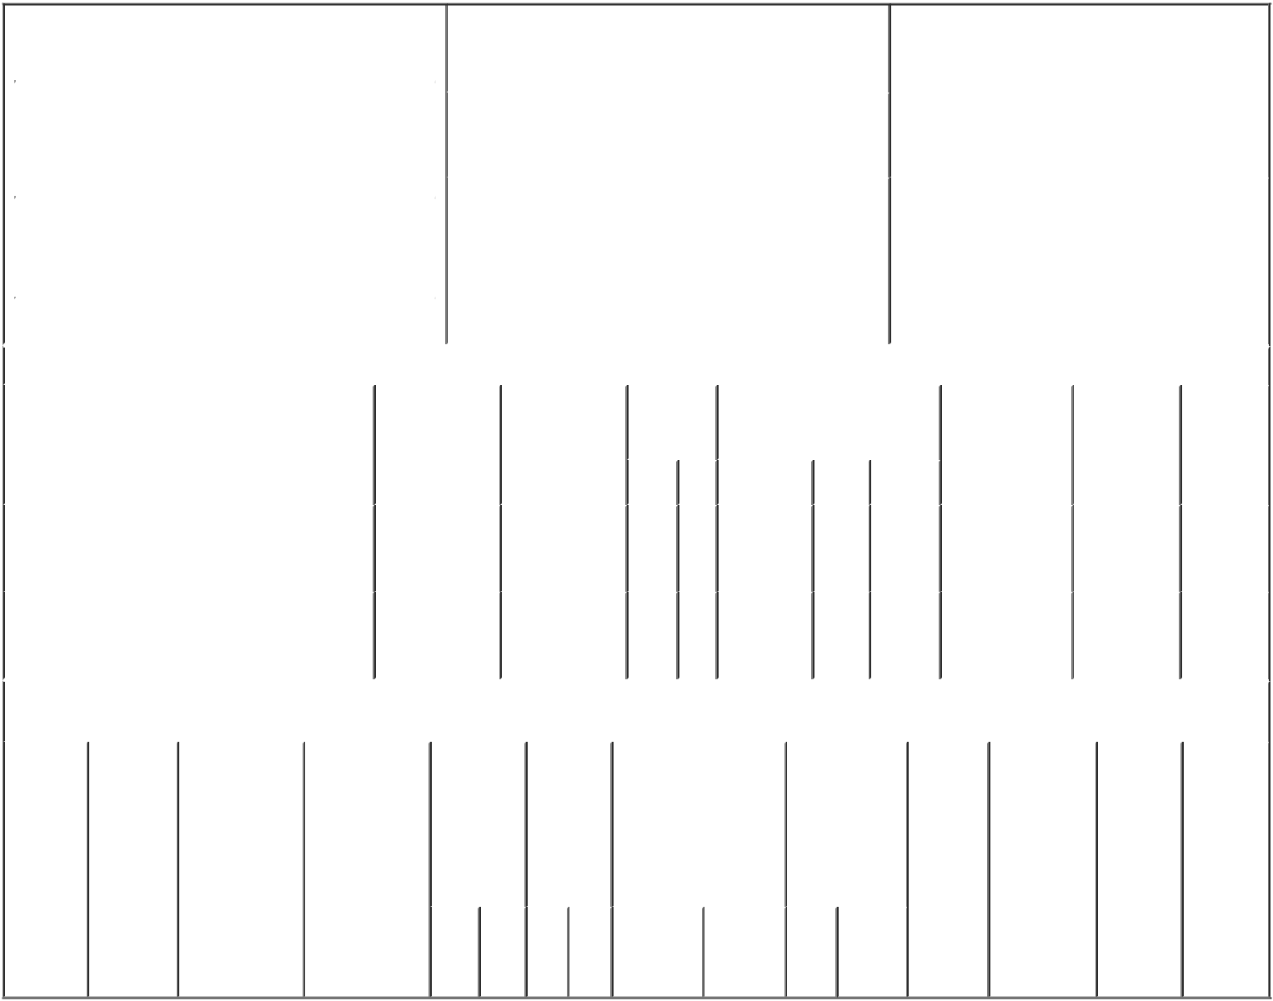

 | 1. Name and Address of Reporting Person* |  |  |  |  |  |  |  |  |  | 2. Issuer Name and Ticker or Trading Symbol |  |  |  |  |  |  |  |  |  | 5. Relationship of Reporting Person(s) to Issuer
 |  | Wedell-Wedellsborg Johan |  |  |  |  |  |  |  |  | Y-mAbs Therapeutics, Inc. [ YMAB ] |  |  |  |  |  |  |  |  |  | (Check all applicable)
 |  |  |  |  |  |  |  |  |  |  |  |  |  |  |  |  |  |  |  |  |  | X | Director |  | X 10% Owner
 |  |  |  |  |  |  |  |  |  |  |  |  |  |  |  |  |  |  |  |  |  |  | Officer (give title |  | Other (specify
 |  | (Last) |  | (First) |  |  | (Middle) |  |  |  | 3. Date of Earliest Transaction (Month/Day/Year) |  |  |  |  |  |  |  |  |  |  |  | below) |  | below)
 |  | C/O WECO GROUP A/S |  |  |  |  |  |  | 07/15/2019
 |  | RUNGSTED STRANDVEJ 113
 |  |  |  |  |  |  |  |  |  |  | 4. If Amendment, Date of Original Filed (Month/Day/Year) |  |  |  |  |  |  |  |  |  | 6. Individual or Joint/Group Filing (Check Applicable
 | (Street) |  |  |  |  |  |  |  | 07/17/2019 |  |  |  |  |  |  |  |  |  |  |  | Line)
 |  | RUNGSTED |  | G7 |  |  | 2960 |  |  |  |  |  |  |  |  |  |  |  |  |  |  | X Form filed by One Reporting Person
 |  |  |  |  |  |  |  |  |  |  |  |  |  |  |  |  |  |  |  |  |  |  | Form filed by More than One Reporting
 |  | KYST
 |  |  |  |  |  |  |  |  |  |  |  |  |  |  |  |  |  |  |  |  |  |  | Person
 |  | (City) |  | (State) |  |  | (Zip)
 |  |  |  |  | Table I - Non-Derivative Securities Acquired, Disposed of, or Beneficially Owned
 | 1. Title of Security (Instr. 3) |  |  |  |  |  | 2. Transaction |  |  |  |  | 2A. Deemed |  | 3. |  |  | 4. Securities Acquired (A) or |  |  |  |  |  | 5. Amount of |  | 6. Ownership | 7. Nature
 |  |  |  |  |  |  | Date |  |  |  |  | Execution Date, |  |  | Transaction |  | Disposed Of (D) (Instr. 3, 4 and |  |  |  |  |  | Securities |  | Form: Direct | of Indirect
 |  |  |  |  |  |  | (Month/Day/Year) |  |  |  |  | if any |  |  | Code (Instr. | 5) |  |  |  |  |  |  | Beneficially |  | (D) or Indirect | Beneficial
 |  |  |  |  |  |  |  |  |  |  |  | (Month/Day/Year) |  | 8) |  |  |  |  |  |  |  |  | Owned Following |  | (I) (Instr. 4) | Ownership
 |  |  |  |  |  |  |  |  |  |  |  |  |  |  |  |  |  |  |  |  |  |  | Reported |  |  | (Instr. 4)
 |  |  |  |  |  |  |  |  |  |  |  |  |  |  | Code V |  | Amount | (A) or |  | Price |  |  | Transaction(s)
 |  |  |  |  |  |  |  |  |  |  |  |  |  |  |  |  |  | (D) |  |  |  |  | (Instr. 3 and 4)
 |  |  |  |  |  |  |  |  |  |  |  |  |  |  |  |  |  |  |  |  |  |  |  |  |  | By Weco
 | Common Stock |  |  |  |  |  | 07/15/2019 |  |  |  |  |  |  |  | J | 860,105 |  |  | D | (1) |  |  | 823,392 |  | I | Group
 |  |  |  |  |  |  |  |  |  |  |  |  |  |  |  |  |  |  |  |  |  |  |  |  |  | A/S⁽²⁾
 |  |  |  |  |  |  |  |  |  |  |  |  |  |  |  |  |  |  |  |  |  |  |  |  |  | By WG
 | Common Stock |  |  |  |  |  |  |  |  |  |  |  |  |  |  |  |  |  |  |  |  |  | 5,010,000 |  | I | Biotech
 |  |  |  |  |  |  |  |  |  |  |  |  |  |  |  |  |  |  |  |  |  |  |  |  |  | ApS⁽³⁾
 |  |  |  |  |  | Table II - Derivative Securities Acquired, Disposed of, or Beneficially Owned
 |  |  |  |  |  |  | (e.g., puts, calls, warrants, options, convertible securities)
 | 1. Title of |  | 2. |  | 3. Transaction |  | 3A. Deemed |  | 4. |  |  |  | 5. Number | 6. Date Exercisable and |  |  |  | 7. Title and |  |  |  | 8. Price of |  | 9. Number of | 10. | 11. Nature
 | Derivative |  | Conversion |  | Date |  | Execution Date, |  | Transaction |  |  |  | of | Expiration Date |  |  |  | Amount of |  |  |  | Derivative |  | derivative | Ownership | of Indirect
 | Security |  | or Exercise |  | (Month/Day/Year) |  | if any |  | Code (Instr. |  |  |  | Derivative | (Month/Day/Year) |  |  |  | Securities |  |  |  | Security |  | Securities | Form: | Beneficial
 | (Instr. 3) |  | Price of |  |  |  | (Month/Day/Year) |  | 8) |  |  |  | Securities |  |  |  |  | Underlying |  |  |  | (Instr. 5) |  | Beneficially | Direct (D) | Ownership
 |  |  | Derivative |  |  |  |  |  |  |  |  |  | Acquired |  |  |  |  | Derivative |  |  |  |  |  | Owned | or Indirect | (Instr. 4)
 |  |  | Security |  |  |  |  |  |  |  |  |  | (A) or |  |  |  |  | Security (Instr. 3 |  |  |  |  |  | Following | (I) (Instr. 4)
 |  |  |  |  |  |  |  |  |  |  |  |  | Disposed |  |  |  |  | and 4) |  |  |  |  |  | Reported
 |  |  |  |  |  |  |  |  |  |  |  |  | of (D) |  |  |  |  |  |  |  |  |  |  | Transaction(s)
 |  |  |  |  |  |  |  |  |  |  |  |  | (Instr. 3, 4 |  |  |  |  |  |  |  |  |  |  | (Instr. 4)
 |  |  |  |  |  |  |  |  |  |  |  |  | and 5)
 |  |  |  |  |  |  |  |  |  |  |  |  |  |  |  |  |  |  | Amount
 |  |  |  |  |  |  |  |  |  |  |  |  |  |  |  |  |  |  | or
 |  |  |  |  |  |  |  |  |  |  |  |  |  |  |  |  |  |  | Number
 |  |  |  |  |  |  |  |  |  |  |  |  |  | Date |  | Expiration |  |  | of
 |  |  |  |  |  |  |  |  | Code V |  |  |  | (A) (D) | Exercisable |  | Date |  | Title | Shares

Explanation of Responses:

- Weco Group A/S transferred (a) 540,105 shares of the Common Stock of Y-mAbs Therapeutics, Inc. (the "Company") to shareholders of WG Biotech ApS in exchange for 10,781 ordinary shares of WG Biotech ApS; and (b) 320,000 shares of the Company's Common Stock to shareholders of Weco Biotech ApS in exchange for 20,000 shares of Weco Biotech ApS. The closing sale price of the Company's Common Stock on July 15, 2019, the date of the transaction, was $22.95.

- Reporting Person is the majority owner of Weco Group A/S and as such has sole voting and dispositive power with respect to such shares.

- Reporting Person is the majority owner of WG Biotech ApS and as such has sole voting and dispositive power with respect to such shares.

/s/ Johan Wedell-Wedellsborg | 08/26/2019
** Signature of Reporting Person | Date

Reminder: Report on a separate line for each class of securities beneficially owned directly or indirectly.

* If the form is filed by more than one reporting person, see Instruction 4 (b)(v).

- Intentional misstatements or omissions of facts constitute Federal Criminal Violations See 18 U.S.C. 1001 and 15 U.S.C. 78ff(a). Note: File three copies of this Form, one of which must be manually signed. If space is insufficient, see Instruction 6 for procedure.
Persons who respond to the collection of information contained in this form are not required to respond unless the form displays a currently valid OMB Number.

