UNITED STATES

SECURITIES AND EXCHANGE COMMISSION

WASHINGTON, D.C. 20549

SCHEDULE TO

Tender Offer Statement Pursuant to Section 14(d)(1) or 13(e)(1)

of the Securities Exchange Act of 1934

Y-MABS THERAPEUTICS, INC.

(Name of Subject Company)

YOSEMITE MERGER SUB, INC.

(Offeror)

A Wholly Owned Subsidiary of

PERSEUS BIDCO US, INC.

(Parent of Offeror)

Common Stock, Par Value $0.0001 Per Share

(Title of Class of Securities)

984241109

(CUSIP Number of Class of Securities)

Robert Duffield

c/o Perseus BidCo US, Inc.

300 Conshohocken State Road, Suite 300

West Conshohocken, Pennsylvania 19428

United States

+1 856 981 7737

(Name, address and telephone number of person authorized to receive notices and communications on behalf of filing persons)

with copies to:

Sebastian L. Fain, Esq.

Paul K. Humphreys, Esq.

Freshfields US LLP

3 World Trade Center

175 Greenwich Street

New York, NY 10007

 | CALCULATION OF FILING FEE
Transaction Valuation* |  | Amount of Filing Fee*
Not applicable* |  | Not applicable*
- A filing fee is not required in connection with this filing as it relates solely to preliminary communications made before the commencement of a tender offer.

☐Check the box if any part of the fee is offset as provided by Rule 0-11(a)(2) and identify the filing with which the offsetting fee was previously paid.

Identify the previous filing by registration statement number, or the Form or Schedule and the date of its filing.

Amount Previously Paid:

Form of Registration No.:

Filing Party:

Date Filed:

Not applicable.

Not applicable.

Not applicable.

Not applicable.

- Check the box if the filing relates solely to preliminary communications made before the commencement of a tender offer. Check the appropriate boxes below to designate any transactions to which the statement relates:

  - third-party tender offer subject to Rule 14d-1.

- issuer tender offer subject to Rule 13e-4.

- going-private transaction subject to Rule 13e-3.

- amendment to Schedule 13D under Rule 13d-2.

Check the following box if the filing is a final amendment reporting the results of the tender offer: ☐

If applicable, check the appropriate box(es) below to designate the appropriate rule provision(s) relied upon:

- Rule 13e-4(i) (Cross-Border Issuer Tender Offer)

- Rule 14d-1(d) (Cross-Border Third-Party Tender Offer)

This filing relates solely to preliminary communications made before the commencement of a tender offer by Yosemite Merger Sub, Inc., a Delaware corporation (“Purchaser”), a wholly owned subsidiary of Perseus BidCo US, Inc., a Delaware corporation (“SERB Pharmaceuticals”), for all of the outstanding shares of common stock, par value $0.0001 per share (“Shares”), of Y-mAbs Therapeutics, Inc., a Delaware corporation (the “Company”), at a price of $8.60 per Share, in cash, without interest, subject to any applicable withholding of taxes, pursuant to an Agreement and Plan of Merger, dated as of August 4, 2025 (the “Merger Agreement”), by and among SERB Pharmaceuticals, Purchaser, the Company, and solely for the purposes of Section 5.16 and Article 8 of the Merger Agreement, Stark International Lux, a Luxembourg société à responsabilité limitée.

Forward Looking Statements

This announcement contains forward-looking statements that involve risks and uncertainties relating to future events and the future performance of the Company and SERB Pharmaceuticals, including statements relating to the ability to complete and the timing of completion of the transactions contemplated by the Agreement and Plan of Merger dated as of August 4, 2025 by and among the Company, SERB Pharmaceuticals, and the other parties thereto (the “Merger Agreement”), including the anticipated occurrence, manner and timing of the proposed tender offer, the parties’ ability to satisfy the conditions to the consummation of the tender offer and the other conditions to the consummation of the subsequent merger set forth in the Merger Agreement, the possibility of any termination of the Merger Agreement, and the prospective benefits of the proposed transaction, including with respect to the potential for additional data for DANYELZA® (naxitamab-gqgk), the potential expansion of partnerships to additional oncology centers, the ability to have a positive impact on the lives of more neuroblastoma patients and their families and SERB Pharmaceuticals’ ability to leverage its existing global footprint and its medical, regulatory, and commercial expertise to expand the reach of DANYELZA to new markets; and other statements that are not historical facts. The forward-looking statements contained in this announcement are based on current expectations and assumptions that are subject to risks and uncertainties which may cause actual results to differ materially from the forward-looking statements. These statements may contain words such as “may,” “will,” “would,” “could,” “expect,” “anticipate,” “intend,” “plan,” “believe,” “estimate,” “project,” “seek,” “should,” “strategy,” “future,” “opportunity,” “potential” or other similar words and expressions indicating future results. Risks that may cause these forward-looking statements to be inaccurate include, without limitation: uncertainties as to the timing of the tender offer; uncertainties as to how many of the Company’s stockholders will tender their stock in the offer; the possibility that competing offers or acquisition proposals will be made; the possibility that various closing conditions for the transaction may not be satisfied or waived, including that a governmental entity may prohibit, delay, or refuse to grant approval for the consummation of the transaction (or only grant approval subject to adverse conditions or limitations); the difficulty of predicting the timing or outcome of regulatory approvals or actions, if any; the occurrence of any event, change or other circumstance that could give rise to the termination of the Merger Agreement; the possibility that the transaction does not close; risks related to the parties’ ability to realize the anticipated benefits of the proposed transaction, including the possibility that the expected benefits from the proposed acquisition will not be realized or will not be realized within the expected time period and that the Company and SERB Pharmaceuticals will not be integrated successfully or that such integration may be more difficult, time-consuming or costly than expected; the effects of the transaction on relationships with employees, customers, suppliers, other business partners or governmental entities; negative effects of this announcement or the consummation of the proposed transaction on the market price of the Company’s common stock and/or the Company’s operating results; significant transaction costs; unknown or inestimable liabilities; the risk of litigation and/or regulatory actions related to the proposed transaction; SERB Pharmaceuticals’ ability to fund the proposed transaction; obtaining and maintaining adequate coverage and reimbursement for products; the time-consuming and uncertain regulatory approval process; the costly and time-consuming pharmaceutical product development process and the uncertainty of clinical success, including risks related to failure or delays in successfully initiating or completing clinical trials and assessing patients; global economic, financial, and healthcare system disruptions and the current and potential future negative impacts to the parties’ business operations and financial results; the sufficiency of the parties’ cash flows and capital resources; the parties’ ability to achieve targeted or expected future financial performance and results and the uncertainty of future tax, accounting and other provisions and estimates; and other risks and uncertainties affecting the Company and SERB Pharmaceuticals, including those described from time to time under the caption “Risk Factors” and elsewhere in the Company’s filings and reports with the U.S. Securities and Exchange Commission (the “SEC”), including the Company’s Annual Report on Form 10-K for the fiscal year ended December 31, 2024 and Quarterly Report on Form 10-Q for the quarterly period ended March 31, 2025, as well as the Tender Offer Statement on Schedule TO and related tender offer documents to be filed by SERB Pharmaceuticals and Purchaser, and the Solicitation/Recommendation Statement on Schedule 14D-9 to be filed by the Company. Any forward-looking statements are made based on the current beliefs and judgments of the Company’s and SERB Pharmaceuticals’ management, and the reader is cautioned not to rely on any forward-looking statements made by the Company or SERB Pharmaceuticals. Except as required by law, the Company and SERB Pharmaceuticals do not undertake any obligation to update (publicly or otherwise) any forward-looking statement, including without limitation any financial projection or guidance, whether as a result of new information, future events, or otherwise.

Important Information about the Offer and Where to Find It

The tender offer (the “Offer”) for the Company’s outstanding common stock referred to in this announcement has not yet commenced. The description contained in this announcement is neither an offer to purchase nor a solicitation of an offer to sell any securities, nor is it a substitute for the tender offer materials that SERB Pharmaceuticals will file with the SEC. The solicitation and offer to purchase the Company’s common stock will only be made pursuant to an offer to purchase and related tender offer materials. At the time the Offer is commenced, SERB Pharmaceuticals will file a tender offer statement on Schedule TO and thereafter the Company will file a solicitation/recommendation statement on Schedule 14D-9 with the SEC with respect to the Offer.

THE TENDER OFFER MATERIALS (INCLUDING AN OFFER TO PURCHASE, A RELATED LETTER OF TRANSMITTAL AND CERTAIN OTHER OFFER DOCUMENTS) AND THE SOLICITATION/RECOMMENDATION STATEMENT ON SCHEDULE 14D-9, AS THEY MAY BE AMENDED OR SUPPLEMENTED FROM TIME TO TIME, WILL CONTAIN IMPORTANT INFORMATION. ANY HOLDERS OF THE COMPANY’S SHARES ARE URGED TO READ THESE DOCUMENTS CAREFULLY WHEN THEY BECOME AVAILABLE BECAUSE THEY WILL CONTAIN IMPORTANT INFORMATION THAT HOLDERS SHOULD CONSIDER BEFORE MAKING ANY DECISION REGARDING TENDERING THEIR SHARES.

The offer to purchase, the letter of transmittal, the solicitation/recommendation statement and related offer documents will be made available for free at the SEC’s website at www.sec.gov. Copies of those offer documents and all other documents filed by SERB Pharmaceuticals and the Company will be made available at no charge by directing a request to the information agent for the Offer, which will be named in the Schedule TO to be filed with the SEC. Copies of the solicitation/recommendation statement on Schedule 14D-9 to be filed with the SEC by the Company will be available free of charge on the Company’s investor relations website at https://ir.ymabs.com/ or by contacting the Company’s investor relations contact at cdu@ymabs.com.

IN ADDITION, THE COMPANY FILES ANNUAL, QUARTERLY AND CURRENT REPORTS AND OTHER INFORMATION WITH THE SEC, WHICH ARE ALSO MADE AVAILABLE FREE OF CHARGE ON THE COMPANY’S INVESTOR RELATIONS WEBSITE AT HTTPS://IR.YMABS.COM/ AND AT THE SEC’S WEBSITE AT WWW.SEC.GOV.

 |  |  | EXHIBIT INDEX
 | Exhibit
 | No. |  | Description
99.1 |  | Joint Press Release issued by SERB Pharmaceuticals and the Company, dated August 5, 2025.
99.2 |  | Social media posts of SERB Pharmaceuticals and Vanessa Wolfeler, President of SERB Pharmaceuticals, dated August 5, 2025.
99.3 |  | News article published by Endpoints: Specialty pharma SERB to buy Y-mAbs in $412M all-cash deal, by Kyle LaHucik, dated August
 |  | 5, 2025.

Exhibit 99.1

FOR IMMEDIATE RELEASE

SERB Pharmaceuticals Agrees to Acquire Y-mAbs Therapeutics

Acquisition to Include DANYELZA® (Naxitamab-gqgk), Further Broadening SERB’s Rare Oncology Product Portfolio

Transaction Expands SERB’s Investment in the U.S.

SERB to Commence All-Cash Tender Offer to Acquire All Outstanding Shares of Y-mAbs for $8.60 Per Share

Represents 105% Premium to Y-mAbs Closing Share Price on August 4, 2025

WEST CONSHOHOCKEN, PA and PRINCETON, NJ, August 5, 2025 – SERB Pharmaceuticals (“SERB”), a global specialty pharmaceutical company focused on medicines for rare diseases and medical emergencies, and Y-mAbs Therapeutics, Inc. (Nasdaq: YMAB) (“Y-mAbs” or “the Company”), a commercial-stage biopharmaceutical company focused on the development and commercialization of antibody-based therapeutics for the treatment of cancer, today announced that they have entered into a definitive merger agreement under which SERB will acquire Y-mAbs, including its lead
commercial oncology asset, DANYELZA® (naxitamab-gqgk), in an all-cash transaction, representing an equity value for Y-mAbs of approximately $412 million.

Under the terms of the merger agreement, SERB will commence an all-cash tender offer to purchase all outstanding shares of Y-mAbs common stock. Holders of Y-mAbs common stock would receive $8.60 per share in cash, representing a premium of approximately 105% to Y-mAbs’ closing share price on August 4, 2025, the last full trading day prior to the transaction announcement.

The transaction was unanimously approved by the Y-mAbs Board of Directors following a review of strategic alternatives to maximize value for Y-mAbs stockholders, with the assistance of external advisors. The process included discussions with numerous potential buyers for Y-mAbs or for the DANYELZA or Radiopharmaceuticals businesses on a standalone basis. In addition, the Board reviewed potential sources of additional capital to support accelerating the further development of the Company’s pipeline.

With a focus on pediatric oncology, Y-mAbs successfully developed and commercialized the anti-GD2 therapy, DANYELZA (naxitamab-gqgk). DANYELZA is the first FDA-approved treatment for relapsed or refractory high-risk neuroblastoma – a rare and aggressive pediatric cancer – and was approved in the United States under accelerated approval based on overall response rate and duration of response. DANYELZA is indicated for the treatment of pediatric patients one year of age and older and adult patients with relapsed or refractory high-risk neuroblastoma in the bone or bone marrow who have demonstrated a partial response, minor response, or stable disease to prior therapy. In addition to inpatient use, doctors can choose to administer DANYELZA in an outpatient setting, which may reduce the logistical burden on patients and their families. Y-mAbs’ portfolio also includes an investigational therapy targeting GD2 in solid tumors and CD38 in circulating tumors in ongoing Phase 1 clinical trial from its Self-Assembly DisAssembly (“SADA”) Pretargeted Radioimmunotherapy Platform (“PRIT”).

Vanessa Wolfeler, Chief Executive Officer of SERB: “High-risk neuroblastoma is not only a rare and devastating pediatric cancer but also one of the most difficult to treat. DANYELZA is recognized as a critical treatment option for patients and expands the treatment pathways available to providers in an outpatient setting. Working together with the team from Y-mAbs, I believe we can continue generating data for this product, expand partnerships to additional oncology centers, and have a positive impact on the lives of more neuroblastoma patients and their families.”

Jeremie Urbain, Chairman of SERB: “Following SERB’s expansion into the United States five years ago, this acquisition reflects another milestone in the execution of our growth strategy to build a leading global specialty pharma platform. DANYELZA is an excellent strategic fit for SERB as it strengthens our existing rare oncology portfolio and will allow us to leverage our existing global footprint and our medical, regulatory, and commercial expertise to expand the reach of DANYELZA to new markets.”

SERB has a growing portfolio of medicines for rare emergency medicine, rare diseases, and CBRN preparedness, supplying healthcare providers around

the world. The acquisition of DANYELZA broadens SERB’s existing Rare Oncology portfolio (Voraxaze®, Vistogard®, Xermelo®) and furthers its mission of building a leading portfolio of medicines that improve the standard of care for patients globally.

Michael Rossi, President, Chief Executive Officer and a member of the Board of Directors, Y-mAbs: “Our Board regularly reviews our business, including our strategy, the current state of the biopharmaceutical sector and the time and resources required to execute on our strategic plans. Following the thorough process to explore all of the potential paths forward for the Company, we are now moving forward with this agreement with SERB that we believe reflects the most attractive option available to Y-mAbs, providing significant, immediate and certain value to our stockholders.”

Mr. Rossi continued: “This transaction is a testament to our team’s hard work in building a strong foundation as a commercial organization with a differentiated, FDA-approved product in DANYELZA. We believe that Y-mAbs has made important progress advancing DANYELZA and our Radiopharmaceuticals platform. By combining our expertise and resources with SERB’s specialty commercial capabilities, we can extend our shared commitment of improving the lives of even more patients and families on a global scale.”

Transaction Details

Under the terms of the merger agreement, SERB is obligated to commence a tender offer by August 19, 2025, to purchase all of Y-mAbs’ outstanding shares for $8.60 per share in cash. Assuming a majority of the outstanding Y-mAbs shares are tendered into, and not withdrawn from, the tender offer, and subject to the satisfaction of other customary conditions, including the receipt of a majority of Y-mAbs shares in the tender offer and expiration or termination of the applicable waiting period under the Hart-Scott-Rodino Antitrust Improvements Act, SERB is required to close the tender offer, following which, Y-mAbs will be merged with a subsidiary of SERB. After such merger, Y-mAbs shares that were not tendered in the tender offer will be converted into the right to receive the same $8.60 per share in cash paid for shares in the tender offer, and Y-mAbs’ stock will no longer be listed on the Nasdaq exchange.

Y-mAbs stockholders holding approximately 16% of Y-mAbs’ outstanding shares of common stock have entered into a tender and support agreement with SERB, pursuant to which such stockholders have agreed, among other things, to tender all of their shares of Y-mAbs common stock in the tender offer, subject to the terms and conditions of such agreement.

The transaction is expected to close by the fourth quarter of 2025.

Advisors

Rothschild & Co. is acting as exclusive financial advisor, Freshfields US LLP is acting as legal counsel and H/Advisors Abernathy is acting as strategic communications advisor to SERB.

Centerview Partners is acting as exclusive financial advisor, Cooley LLP is acting as legal counsel and Joele Frank, Wilkinson Brimmer Katcher is acting as strategic communications advisor to Y-mAbs.

About SERB Pharmaceuticals

SERB is a global specialty pharmaceutical company with a growing portfolio of medicines for rare emergency medicine, rare diseases, and CBRN preparedness. For over 30 years we have made treating complex and life-threatening conditions possible, supporting clinicians, healthcare systems and governments while offering hope to patients and their families. The company’s Rare Oncology portfolio includes Voraxaze® (glucarpidase), Vistogard®

(uridine triacetate), Xermelo® (telotristat ethyl). SERB is also a leading provider of essential acute care medicines, addressing unmet medical needs and supplying antidotes and medical countermeasures for chemical, biological, radiological and nuclear (CBRN) risks. As a fully integrated company, we have the experience and capabilities to acquire, develop, and manufacture our medicines to the highest standards, and make them available worldwide through our secure supply chain.

Learn more at https://SERB.com

About Y-mAbs

Y-mAbs is a commercial-stage biopharmaceutical company focused on the development and commercialization of novel, radioimmunotherapy and antibody-based therapeutic cancer products. The Company’s broad and advanced commercial product pipeline includes the anti-GD2 therapy
DANYELZA® (naxitamab-gqgk), the first FDA-approved treatment for patients with relapsed or refractory high-risk neuroblastoma in the bone or bone marrow after a partial response, minor response, or stable disease to prior therapy. The Company’s technologies include its investigational Self-Assembly DisAssembly (“SADA”) Pretargeted Radioimmunotherapy Platform (“PRIT”) and bispecific antibodies generated using the Y-BiClone platform.

About DANYELZA® (naxitamab-gqgk)

DANYELZA® (naxitamab-gqgk) is indicated, in combination with granulocyte-macrophage colony-stimulating factor ("GM-CSF"), for the treatment of pediatric patients one year of age and older and adult patients with relapsed or refractory high-risk neuroblastoma in the bone or bone marrow who have demonstrated a partial response, minor response, or stable disease to prior therapy. This indication was approved under accelerated approval based on overall response rate and duration of response. Continued approval for this indication may be contingent upon verification and description of clinical
benefits in a confirmatory trial. DANYELZA® includes a Boxed Warning for serious infusion-related reactions, such as cardiac arrest and anaphylaxis, and neurotoxicity, such as severe neuropathic pain and transverse myelitis. See full Prescribing Information for complete Boxed Warning and other important safety information here.

DANYELZA is currently not approved for the treatment of osteosarcoma in any jurisdiction.

Forward-Looking Statements

This press release contains forward-looking statements that involve risks and uncertainties relating to future events and the future performance of Y-mAbs and SERB, including statements relating to the ability to complete and the timing of completion of the transactions contemplated by the Agreement and Plan of Merger dated as of August 4, 2025 by and among Y-mAbs, SERB, and the other parties thereto (the “Merger Agreement”), including the anticipated occurrence, manner and timing of the proposed tender offer, the parties’ ability to satisfy the conditions to the consummation of the tender offer and the other conditions to the consummation of the subsequent merger set forth in the Merger Agreement, the possibility of any termination of the Merger Agreement, and the prospective benefits of the proposed transaction, including with respect to the potential for additional data for DANYELZA, the potential expansion of partnerships to additional oncology centers, the ability to have a positive impact on the lives of more neuroblastoma patients and their families and SERB’s ability to leverage its existing global footprint and its medical, regulatory, and commercial expertise to expand the reach of DANYELZA to new markets; and other statements that are not historical facts. The forward-looking statements contained in this release are based on current expectations and assumptions that are subject to risks and uncertainties which may cause actual results to differ materially from the forward-looking statements. These statements may contain words such as “may,” “will,” “would,” “could,” “expect,” “anticipate,” “intend,” “plan,” “believe,” “estimate,” “project,” “seek,” “should,” “strategy,” “future,” “opportunity,” “potential” or other similar words and expressions indicating future results. Risks that may cause these forward-looking statements to be inaccurate include, without limitation: uncertainties as to the timing of the tender offer; uncertainties as to how many of Y-mAbs’ stockholders will tender their stock in the offer; the possibility that competing offers or acquisition proposals will be made; the possibility that various closing conditions for the transaction may not be satisfied or waived, including that a governmental entity may prohibit, delay, or refuse to grant approval for the consummation of the transaction (or only grant approval subject to adverse conditions or limitations); the difficulty of predicting the timing or outcome of regulatory approvals or actions, if any; the occurrence of any event, change or other circumstance that could give rise to the termination of the Merger Agreement; the possibility that the transaction does not close; risks related to the parties’ ability to realize the anticipated benefits of the proposed transaction, including the possibility that the expected benefits from the proposed acquisition will not be realized or will not be realized within the expected time period and that Y-mAbs and SERB will not be integrated successfully or that such integration may be more difficult, time-consuming or costly than expected; the effects of the transaction on relationships with employees, customers, suppliers, other business partners or governmental entities; negative effects of this announcement or the consummation of the proposed transaction on the market price of Y-mAbs’ common stock and/or Y-mAbs’ operating results; significant transaction costs; unknown or inestimable liabilities; the risk of litigation and/or regulatory actions related to the proposed transaction; SERB’s ability to fund the proposed transaction; obtaining and maintaining adequate coverage and reimbursement for products; the time-consuming and uncertain regulatory approval process; the costly and time-consuming pharmaceutical product development process and the uncertainty of clinical success, including risks related to failure or delays in successfully initiating or completing clinical trials and assessing patients; global economic, financial, and healthcare system disruptions and the current and potential future negative impacts to the parties’ business operations and financial results; the sufficiency of the parties’ cash flows and capital resources; the parties’ ability to achieve targeted or expected future financial performance and results and the uncertainty of future tax, accounting and other provisions and estimates; and other risks and uncertainties affecting Y-mAbs and SERB, including those described from time to time under the caption “Risk Factors” and elsewhere in Y-mAbs’ filings and reports with the U.S. Securities and Exchange Commission (the “SEC”), including Y-mAbs’ Annual Report on Form 10-K for the fiscal year ended December 31, 2024 and Quarterly Report on Form 10-Q for the quarterly period ended March 31, 2025, as well as the Tender Offer Statement on Schedule TO and related tender offer documents to be filed by SERB and its acquisition subsidiary, and the Solicitation/Recommendation Statement on Schedule 14D-9 to be filed by Y-mAbs. Any forward-looking statements are made based on the current beliefs and judgments of Y-mAbs’ and SERB’s management, and the reader is cautioned not to rely on any forward-looking statements made by Y-mAbs or SERB. Except as required by law, Y-mAbs and SERB do not undertake any obligation to update (publicly or otherwise) any forward-looking statement, including without limitation any financial projection or guidance, whether as a result of new information, future events, or otherwise.

Important Information about the Tender Offer and Where to Find It

The tender offer (the “Offer”) for the Y-mAbs outstanding common stock referred to in this release has not yet commenced. The description contained in this release is neither an offer to purchase nor a solicitation of an offer to sell any securities, nor is it a substitute for the tender offer materials that SERB will file with the SEC. The solicitation and offer to purchase Y-mAbs’ common stock will only be made pursuant to an offer to purchase and related tender offer materials. At the time the Offer is commenced, SERB will file a tender offer statement on Schedule TO and thereafter Y-mAbs will file a solicitation/recommendation statement on Schedule 14D-9 with the SEC with respect to the Offer.

THE TENDER OFFER MATERIALS (INCLUDING AN OFFER TO PURCHASE, A RELATED LETTER OF TRANSMITTAL AND CERTAIN OTHER OFFER DOCUMENTS) AND THE SOLICITATION/RECOMMENDATION STATEMENT ON SCHEDULE 14D-9, AS THEY MAY BE AMENDED OR SUPPLEMENTED FROM TIME TO TIME, WILL CONTAIN IMPORTANT INFORMATION. ANY HOLDERS OF Y-MABS SHARES ARE URGED TO READ THESE DOCUMENTS CAREFULLY WHEN THEY BECOME AVAILABLE BECAUSE THEY WILL CONTAIN IMPORTANT INFORMATION THAT HOLDERS SHOULD CONSIDER BEFORE MAKING ANY DECISION REGARDING TENDERING THEIR SHARES.

The offer to purchase, the letter of transmittal, the solicitation/recommendation statement and related offer documents will be made available for free at the SEC’s website at www.sec.gov. Copies of those offer documents and all other documents filed by SERB and Y-mAbs will be made available at no charge by directing a request to the information agent for the Offer, which will be named in the Schedule TO to be filed with the SEC. Copies of the solicitation/recommendation statement on Schedule 14D-9 to be filed with the SEC by Y-mAbs will be available free of charge on Y-mAbs’ investor relations website at https://ir.ymabs.com/ or by contacting Y-mAbs’ investor relations contact at cdu@ymabs.com.

In addition, Y-mAbs files annual, quarterly and current reports and other information with the SEC, which are also made available free of charge on the Company’s investor relations website at https://ir.ymabs.com/ and at the SEC’s website at www.sec.gov.

CONTACTS

SERB Media

Chris Sampson,

Director, Corporate Communications and ESG

chris.sampson@serb.com

Y-mAbs Investors

Courtney Dugan

VP, Head of Investor Relations

cdu@ymabs.com

Y-mAbs Media

Aaron Palash / Fouad Boutros

Joele Frank, Wilkinson Brimmer Katcher

212-355-4449

Exhibit 99.2
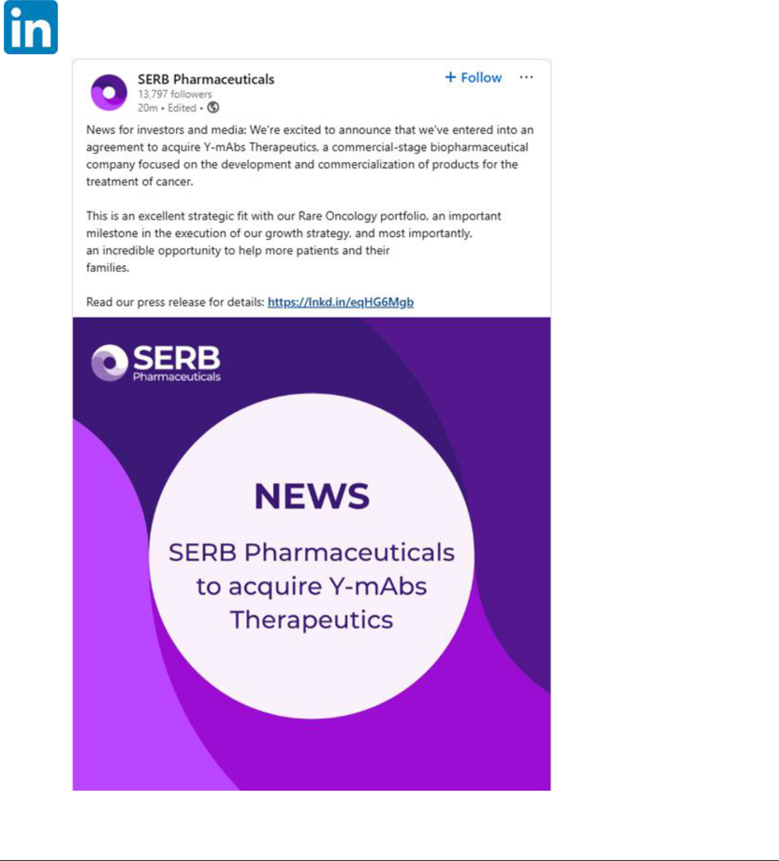

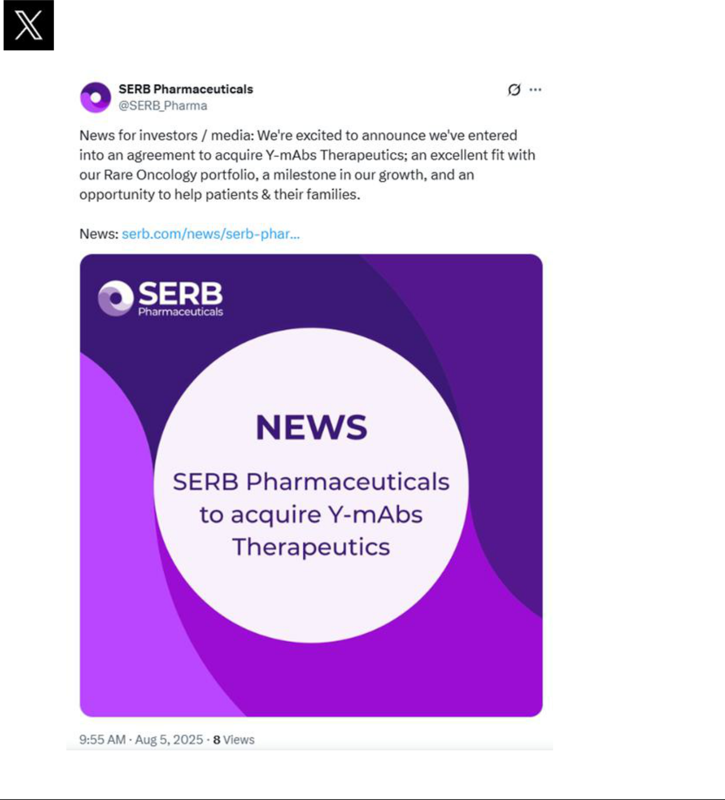

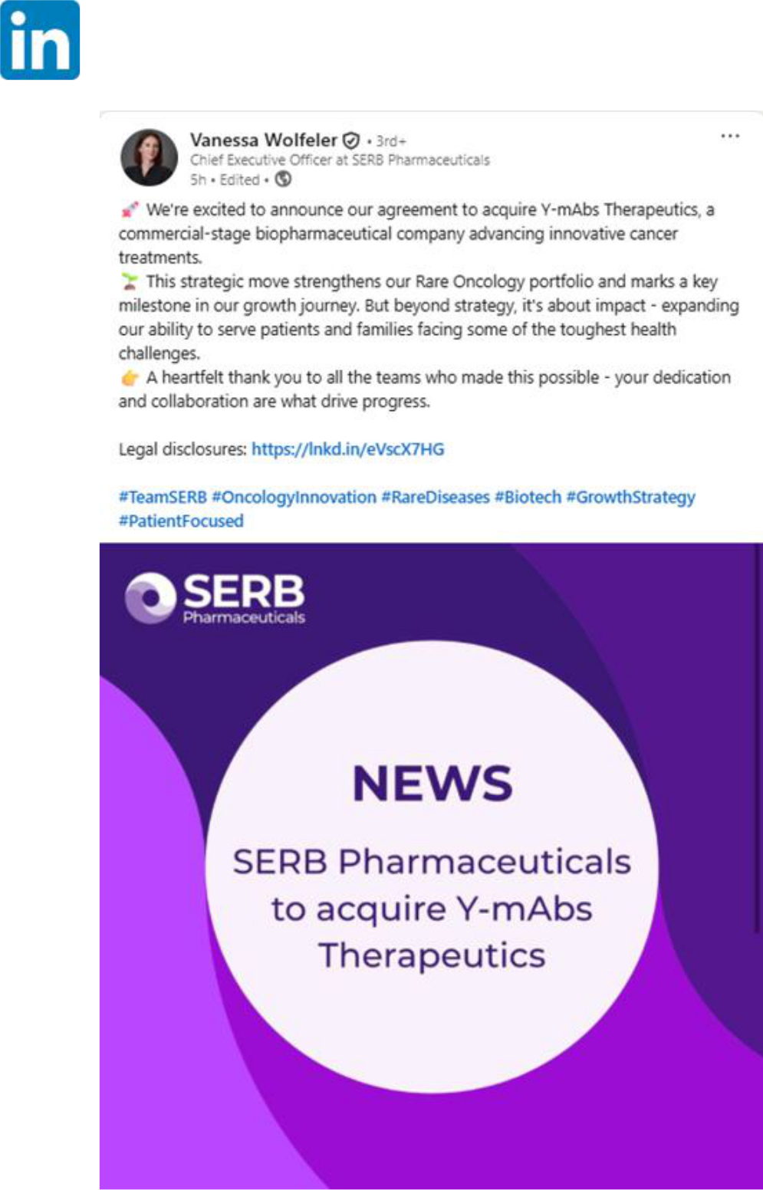

Exhibit 99.3

Specialty pharma SERB to buy Y-mAbs in $412M all-cash deal

Endpoints

5 August 2025

By Kyle LaHucik

Specialty drugmaker SERB Pharmaceuticals plans to buy cancer biotech Y-mAbs Therapeutics to further broaden its portfolio of more than 70 medicines.

SERB will pay $8.60 per share to buy Y-mAbs $YMAB, the companies said Tuesday morning. Y-mAbs’ stock price skyrocketed 103% to $8.51 apiece, nearly matching the buyout price, in afternoon trading.

The all-cash deal places a $412 million equity value on the New Jersey and Danish biotech, which markets a neuroblastoma treatment called Danyelza, a GD2 antibody that was approved in November 2020. In May, the biotech guided to full-year 2025 revenues of $75 million to $90 million.

Over the years, Y-mAbs had faced multiple setbacks, including the FDA’s rejection of its other neuroblastoma drug called omburtamab. It resorted to multiple rounds of layoffs. The company was founded in 2015 by Thomas Gad, whose daughter was diagnosed with high-risk neuroblastoma at a young age. The startup went public via a $96 million IPO in September 2018.

More recently, Y-mAbs had also been building out an early-stage pipeline in the hot radiopharmaceuticals space to pad its longer-term future. SERB CEO Vanessa Wolfeler told Endpoints News that the company will work with Y-mAbs and others to “find the best path for this platform.”

In the deal announcement, Y-mAbs said its sale process involved talks with “numerous potential buyers” for the company, for Danyelza on its own, and for the radiopharmaceutical unit as a standalone. The board also looked at “potential sources of additional capital” to keep its pipeline R&D humming.

A growing pharma

SERB’s Y-mAbs deal could be further augmented by additional acquisitions, Wolfeler said. Business development has been a core strategy for the pharmaceutical company over the years, including last year’s deal to land a frostbite treatment from CiVi Biopharma.

One of its biggest deals to date was the $800 million cash purchase of BTG Specialty Pharmaceuticals. That deal, which closed in 2021, included three drugs that were expected to garner a total of $210 million in revenue in 2020.

SERB plans to continue growing across more disease areas and patient populations, said Wolfeler, who joined last year after leading Sanofi’s US Dupixent business and rare disease franchise. Growth could come via label expansion and new indications for existing treatments and acquisitions.

That growth could also come via geographic expansion. The company directly sells medicines in 18 countries and supplies treatments in more than 100 countries, according to its website.

“We have a lot of products that are not necessarily launched across all geographies, and we have a global platform that we can leverage to continue to expand into new geographies,” Wolfeler said.

SERB is currently about a $400 million-per-year revenue company, Wolfeler said. The goal is to grow to $1 billion per year in revenues, she added.

The company has more than 500 employees, with about one-third each in the US, UK and rest of Europe, the CEO said. It is backed by private equity firms Charterhouse Capital Partners, Partners Group and Mérieux Equity Partners, among others.

Forward-Looking Statements

This communication contains forward-looking statements that involve risks and uncertainties relating to future events and the future performance of Y-mAbs Therapeutics, Inc., a Delaware corporation (“Y-mAbs”), and Perseus BidCo US, Inc., a Delaware corporation (“SERB”), including statements relating to the ability to complete and the timing of completion of the transactions contemplated by the Agreement and Plan of Merger dated as of August 4, 2025 by and among Y-mAbs, SERB, and the other parties thereto (the “Merger Agreement”), including the anticipated occurrence, manner and timing of the proposed tender offer, the parties’ ability to satisfy the conditions to the consummation of the tender offer and the other conditions to the consummation of the subsequent merger set forth in the Merger Agreement, the possibility of any termination of the Merger Agreement, and the prospective benefits of the proposed transaction, including with respect to the potential for additional data for DANYELZA® (naxitamab-gqgk), the potential expansion of partnerships to additional oncology centers, the ability to have a positive impact on the lives of more neuroblastoma patients and their families and SERB’s ability to leverage its existing global footprint and its medical, regulatory, and commercial expertise to expand the reach of DANYELZA to new markets; and other statements that are not historical facts. The forward-looking statements contained in this communication are based on current expectations and assumptions that are subject to risks and uncertainties which may cause actual results to differ materially from the forward-looking statements. These statements may contain words such as “may,” “will,” “would,” “could,” “expect,” “anticipate,” “intend,” “plan,” “believe,” “estimate,” “project,” “seek,” “should,” “strategy,” “future,” “opportunity,” “potential” or other similar words and expressions indicating future results. Risks that may cause these forward-looking statements to be inaccurate include, without limitation: uncertainties as to the timing of the tender offer; uncertainties as to how many of Y-mAbs’ stockholders will tender their stock in the offer; the possibility that competing offers or acquisition proposals will be made; the possibility that various closing conditions for the transaction may not be satisfied or waived, including that a governmental entity may prohibit, delay, or refuse to grant approval for the consummation of the transaction (or only grant approval subject to adverse conditions or limitations); the difficulty of predicting the timing or outcome of regulatory approvals or actions, if any; the occurrence of any event, change or other circumstance that could give rise to the termination of the Merger Agreement; the possibility that the transaction does not close; risks related to the parties’ ability to realize the anticipated benefits of the proposed transaction, including the possibility that the expected benefits from the proposed acquisition will not be realized or will not be realized within the expected time period and that Y-mAbs and SERB will not be integrated successfully or that such integration may be more difficult, time-consuming or costly than expected; the effects of the transaction on relationships with employees, customers, suppliers, other business partners or governmental entities; negative effects of the announcement of the Merger Agreement and the transactions contemplated thereby, or the consummation of the proposed transaction on the market price of Y-mAbs’ common stock and/or Y-mAbs’ operating results; significant transaction costs; unknown or inestimable liabilities; the risk of litigation and/or regulatory actions related to the proposed transaction; SERB’s ability to fund the proposed transaction; obtaining and maintaining adequate coverage and reimbursement for products; the time-consuming and uncertain regulatory approval process; the costly and time-consuming pharmaceutical product development process and the uncertainty of clinical success, including risks related to failure or delays in successfully initiating or completing clinical trials and assessing patients; global economic, financial, and healthcare system disruptions and the current and potential future negative impacts to the parties’ business operations and financial results; the sufficiency of the parties’ cash flows and capital resources; the parties’ ability to achieve targeted or expected future financial performance and results and the uncertainty of future tax, accounting and other provisions and estimates; and other risks and uncertainties affecting Y-mAbs and SERB, including those described from time to time under the caption “Risk Factors” and elsewhere in Y-mAbs’ filings and reports with the U.S. Securities and Exchange Commission (the “SEC”), including Y-mAbs’ Annual Report on Form 10-K for the fiscal year ended December 31, 2024 and Quarterly Report on Form 10-Q for the quarterly period ended March 31, 2025, as well as the Tender Offer Statement on Schedule TO and related tender offer documents to be filed by SERB and its acquisition subsidiary, and the Solicitation/Recommendation Statement on Schedule 14D-9 to be filed by Y-mAbs. Any forward-looking statements are made based on the current beliefs and judgments of Y-mAbs’ and SERB’s management, and the reader is cautioned not to rely on any forward-looking statements made by Y-mAbs or SERB. Except as required by law, Y-mAbs and SERB do not undertake any obligation to update (publicly or otherwise) any forward-looking statement, including without limitation any financial projection or guidance, whether as a result of new information, future events, or otherwise.

Important Information about the Tender Offer and Where to Find It

The tender offer (the “Offer”) for the Y-mAbs outstanding common stock referred to in this communication has not yet commenced. The description contained in this communication is neither an offer to purchase nor a solicitation of an offer to sell any securities, nor is it a substitute for the tender offer materials that SERB will file with the SEC. The solicitation and offer to purchase Y-mAbs’ common stock will only be made pursuant to an offer to purchase and related tender offer materials. At the time the Offer is commenced, SERB will file a tender offer statement on Schedule TO and thereafter Y-mAbs will file a solicitation/recommendation statement on Schedule 14D-9 with the SEC with respect to the Offer.

THE TENDER OFFER MATERIALS (INCLUDING AN OFFER TO PURCHASE, A RELATED LETTER OF TRANSMITTAL AND CERTAIN OTHER OFFER DOCUMENTS) AND THE SOLICITATION/RECOMMENDATION STATEMENT ON SCHEDULE 14D-9, AS THEY MAY BE AMENDED OR SUPPLEMENTED FROM TIME TO TIME, WILL CONTAIN IMPORTANT INFORMATION. ANY HOLDERS OF Y-MABS SHARES ARE URGED TO READ THESE DOCUMENTS CAREFULLY WHEN THEY BECOME AVAILABLE BECAUSE THEY WILL CONTAIN IMPORTANT INFORMATION THAT HOLDERS SHOULD CONSIDER BEFORE MAKING ANY DECISION REGARDING TENDERING THEIR SHARES.

The offer to purchase, the letter of transmittal, the solicitation/recommendation statement and related offer documents will be made available for free at the SEC’s website at www.sec.gov. Copies of those offer documents and all other documents filed by SERB and Y-mAbs will be made available at no charge by directing a request to the information agent for the Offer, which will be named in the Schedule TO to be filed with the SEC. Copies of the solicitation/recommendation statement on Schedule 14D-9 to be filed with the SEC by Y-mAbs will be available free of charge on Y-mAbs’ investor relations website at https://ir.ymabs.com/ or by contacting Y-mAbs’ investor relations contact at cdu@ymabs.com.

In addition, Y-mAbs files annual, quarterly and current reports and other information with the SEC, which are also made available free of charge on the Company’s investor relations website at https://ir.ymabs.com/ and at the SEC’s website at www.sec.gov.

